
TERRAFORM 05
Execute the script shown in the video.
Creating an S3 bucket using terraform
Syntax:
If you need to specify the region then add provider else block not required
provider "aws" {
region = "us-east-1"
}
resource "aws_s3_bucket" "s3_bucket" {
bucket = "my-tf-test-bucketi44555"
}
Commands to be executed
Terraform init
Terraform apply

Note: The acl argument is deprecated — switch to bucket policies or IAM roles for secure, modern access control in Terraform.
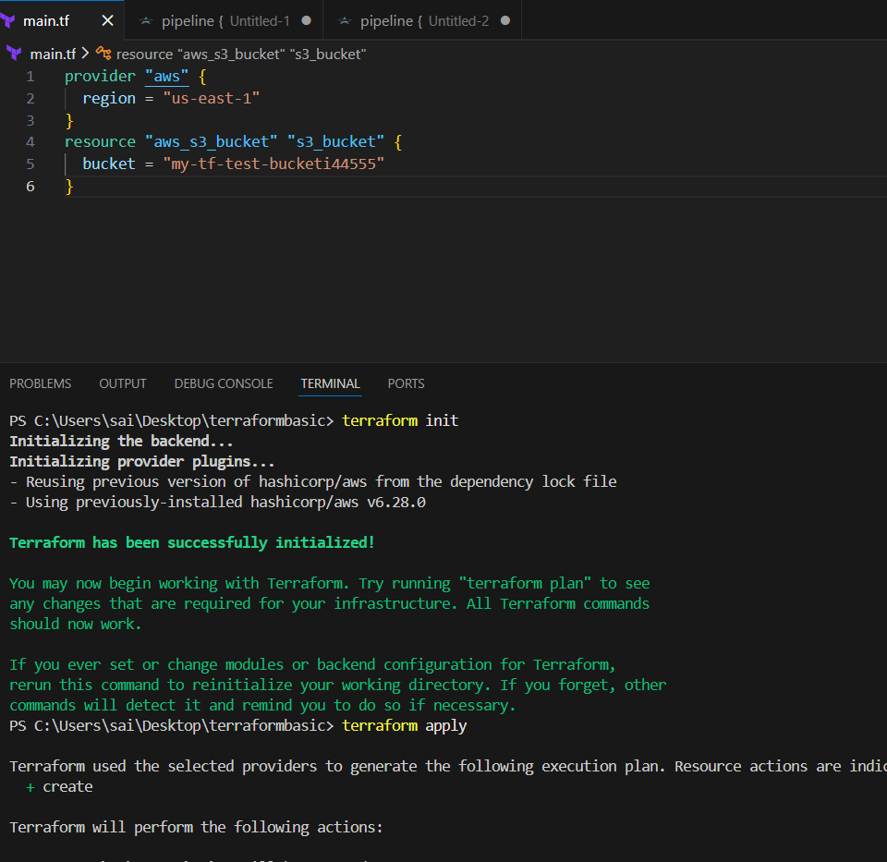
Verified in console
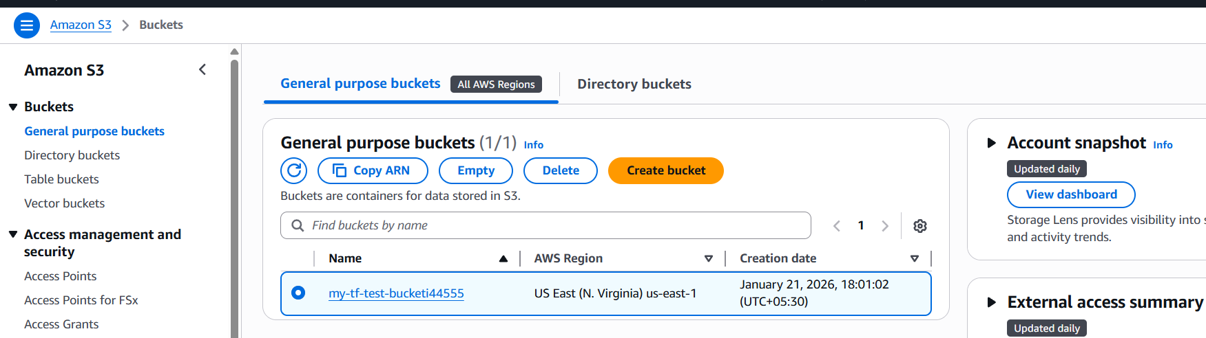

Creating Dynamodb using Terraform
Syntax:
resource "aws_dynamodb_table" "ddb-terraform-backend" {
name = "ddb-terraform-backend"
hash_key = "LockID"
read_capacity = 20
write_capacity = 20
attribute {
name = "LockID"
type = "S"
}
}
Commands:
Terraform init, terraform apply
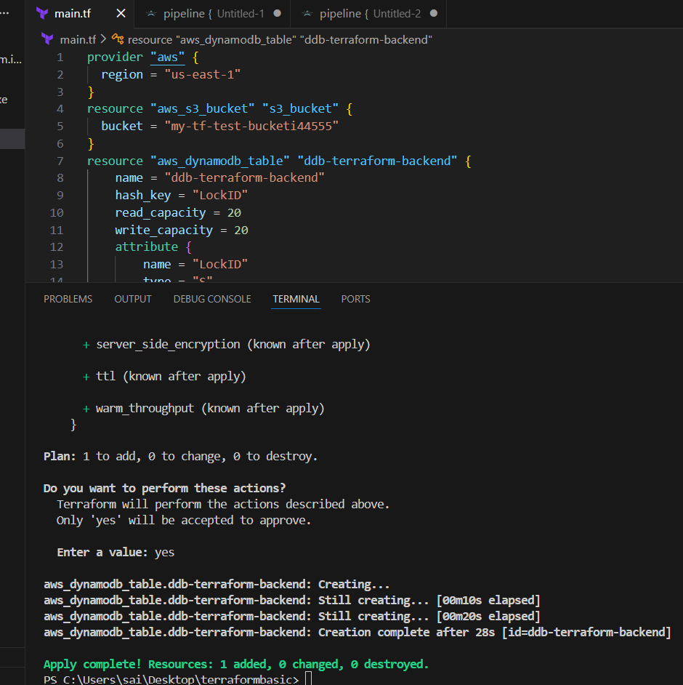
Verified in aws
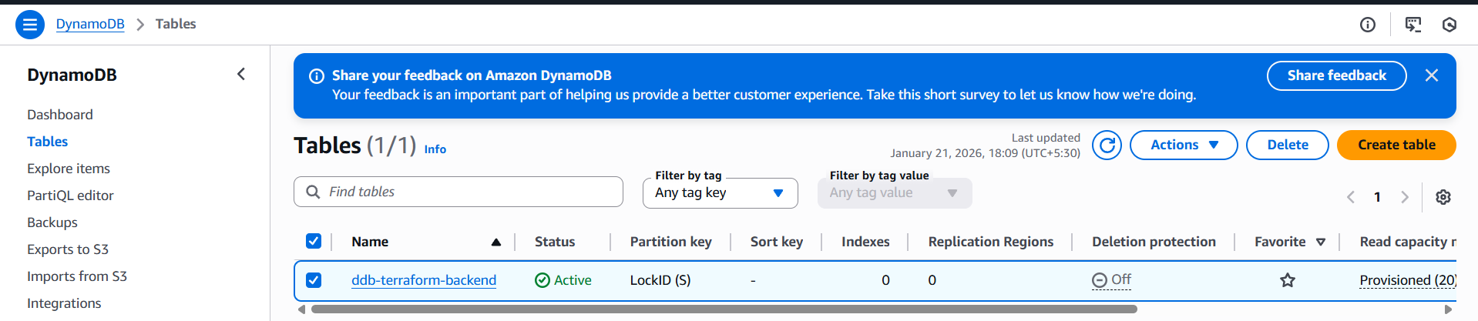

S3 as Backend for Terraform.tf state file
Syntax:
terraform {
backend "s3" {
bucket = "my-tf-test-bucketi44555"
key = "path/to/my/terraform.tfstate"
region = "us-east-1"
dynamodb_table = "ddb-terraform-backend"
}
}
Commands:
Terraform init
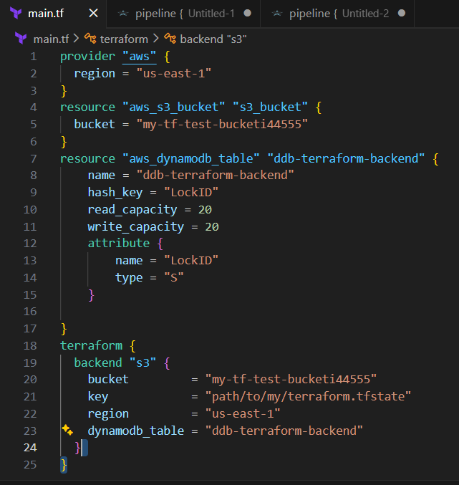
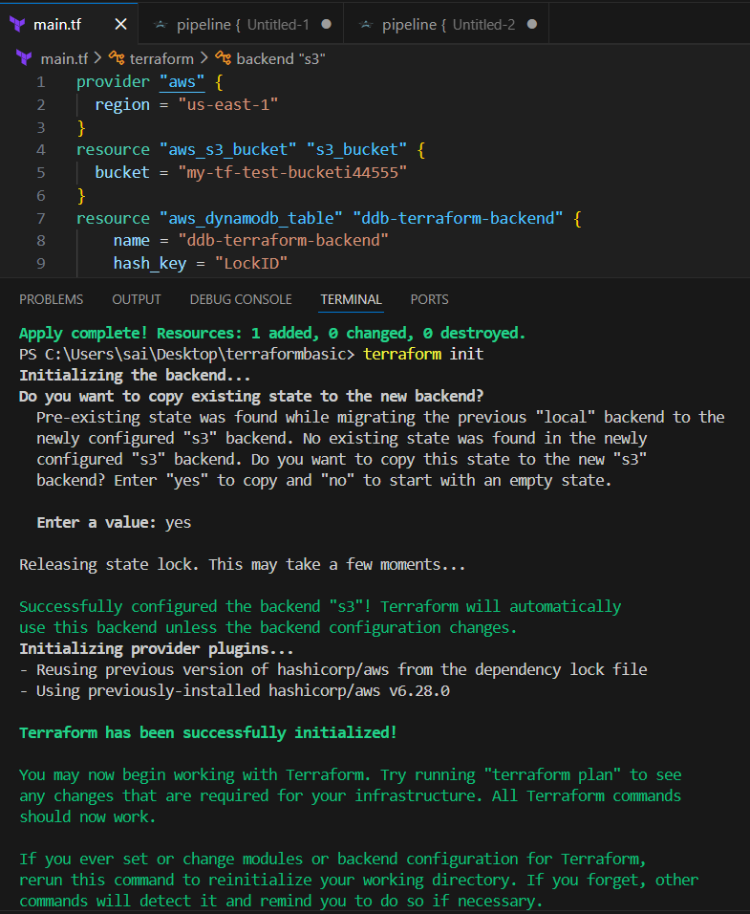

Verified in aws
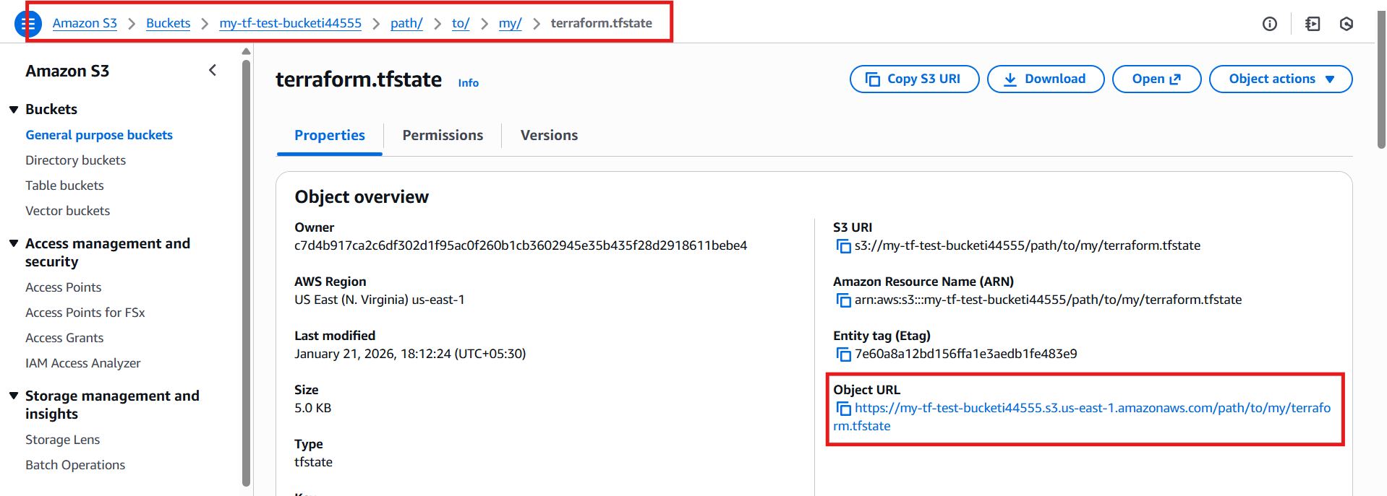

Creating Ec2 Instance Using Terraform
Syntax:
resource "aws_instance" "terraform" {
ami = "ami-07ff62358b87c7116"
instance_type = "t3.micro"
key_name = "sshless"
tags = {
Name = "terraform-instance"
}
}

Commands to use:
Terraform init
Terraform apply

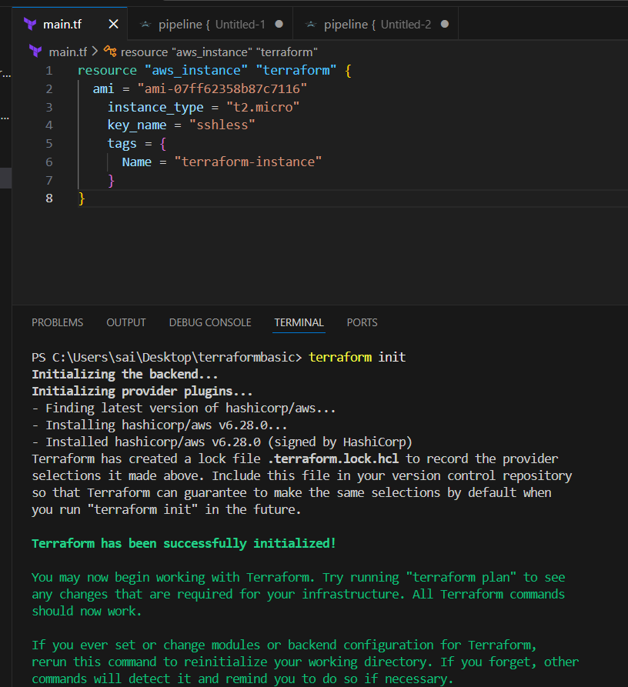
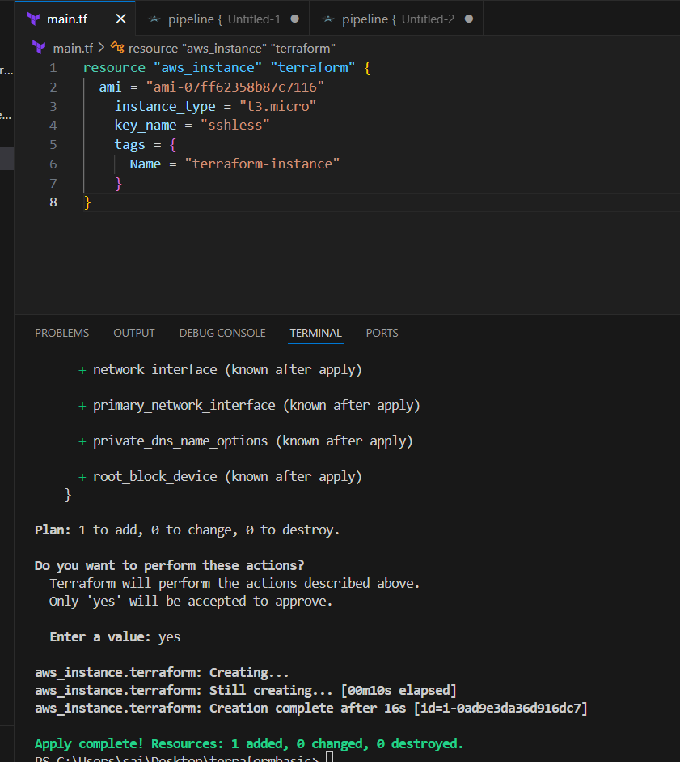
Verified the instance in aws
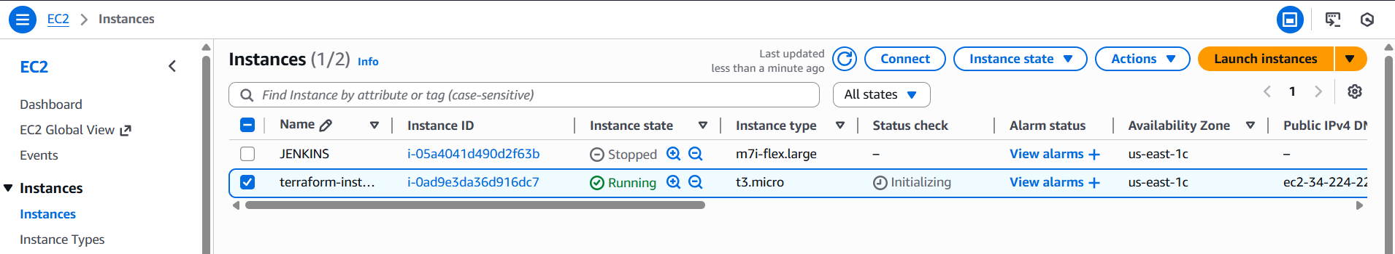

Terraform Provisioners:
Syntax:
resource "aws_instance" "terraform" {
ami = "ami-07ff62358b87c7116"
instance_type = "t3.micro"
key_name = "sshless"
tags = {
Name = "terraform-instance"
}

provisioner "local-exec" {
command = "echo ${aws_instance.terraform.public_ip} > ip_address.txt"
}
}
Commands:
Init and apply

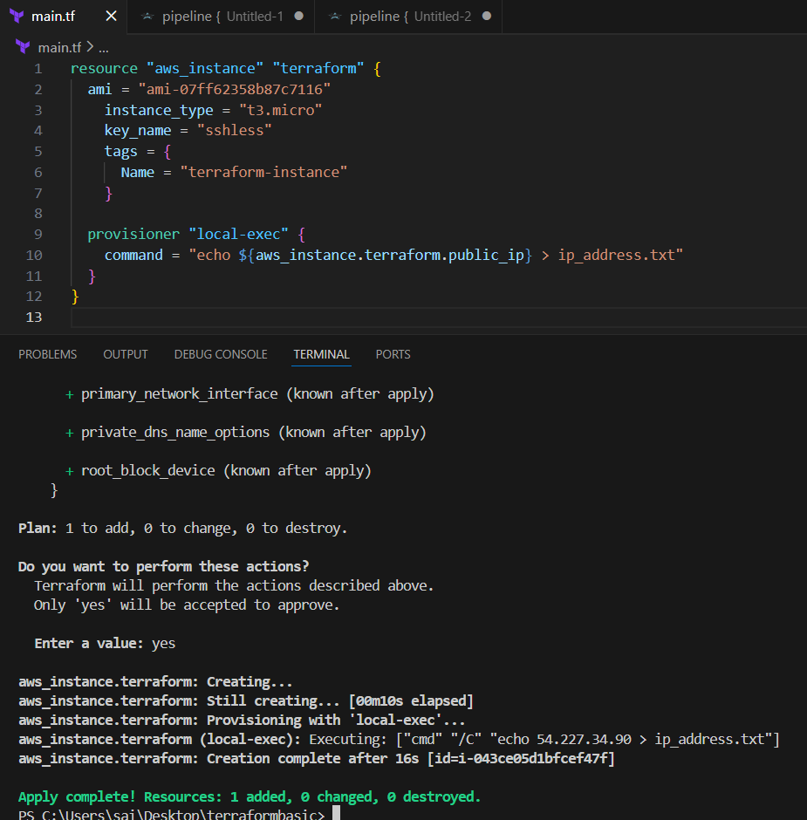
Verified in aws
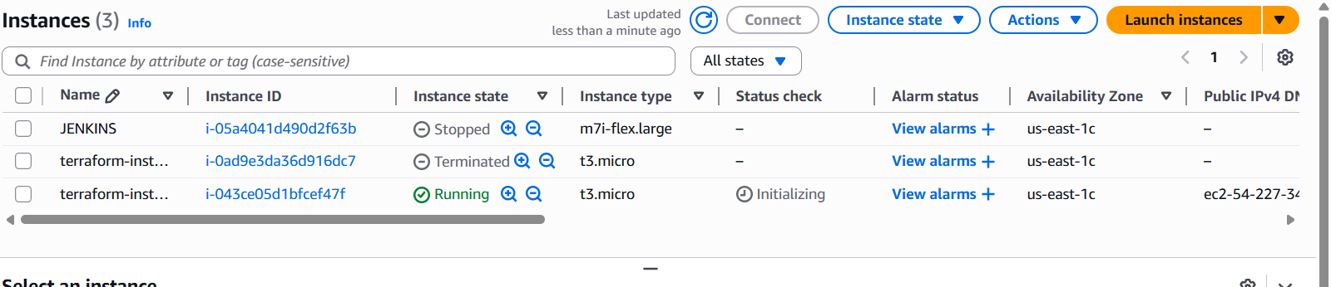

Debugging
Syntax:
resource "aws_instance" "terraform" {
ami = "ami-07ff62358b87c7116"
instance_type = "t3.micro"
key_name = "sshless"
tags = {
Name = "terraform-instance"
}

provisioner "local-exec" {
command = "echo ${aws_instance.terraform.public_ip} > ip_address.txt"
}
}

In Cli add
set-Item -Path env:TF_LOG -Value "TRACE"
Trace is the highest priority it can list much logs
Command : terraform plan
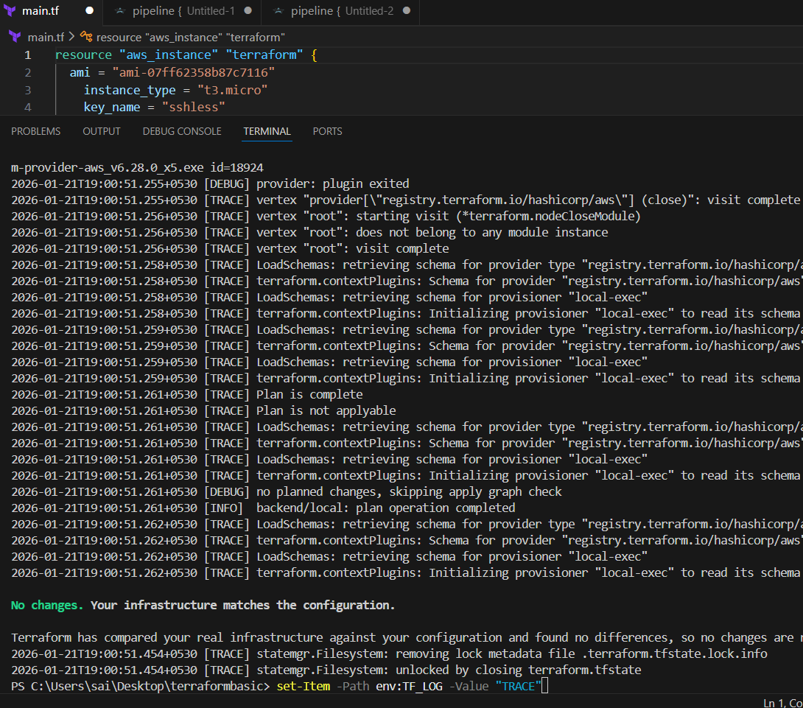
AND IT COIPED THE PUBLIC IP
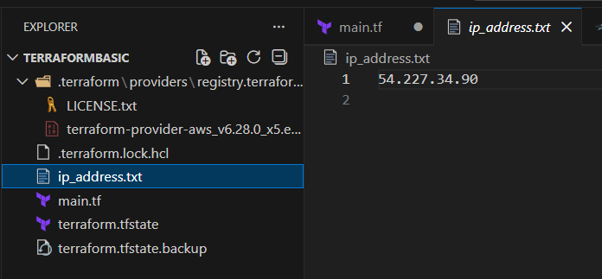

3. Create one EC2 instance with httpd installed using a Terraform script.
Syntax:
resource "aws_instance" "httpd" {
ami = "ami-07ff62358b87c7116"
instance_type = "t3.micro"
key_name = "sshless"
user_data = <<-EOF
#!/bin/bash
sudo yum update -y
sudo yum install -y httpd
sudo systemctl start httpd
sudo systemctl enable httpd
echo "Hello, World from $(hostname -f)" > /var/www/html/index.html
EOF
tags = {
Name = "httpd-instance"
}
provisioner "local-exec" {
command = "echo ${aws_instance.httpd.public_ip} > ip_address.txt"
}
}

Commands:
Init and apply
The ip will be stored in ip_address.txt we can get the public ip from it and we can check through website

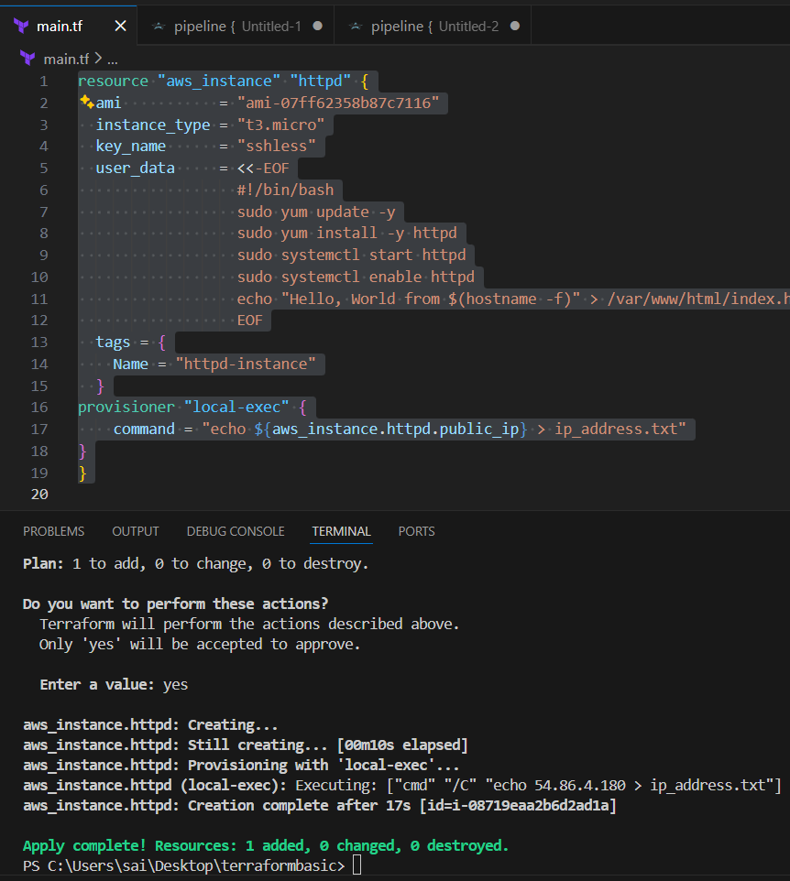
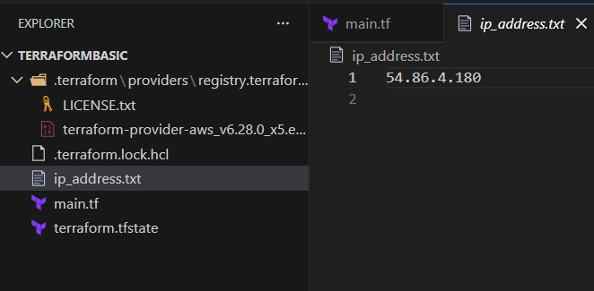
Serach in web
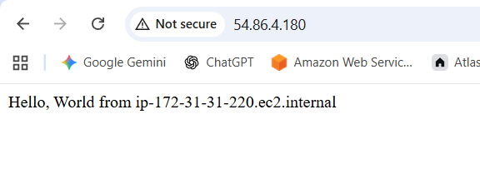
You can change the data as ur wish

4. Set up S3 as backend for task 3.
Syntax:
resource "aws_instance" "httpd" {
ami = "ami-07ff62358b87c7116"
instance_type = "t3.micro"
key_name = "sshless"
user_data = <<-EOF
#!/bin/bash
sudo yum update -y
sudo yum install -y httpd
sudo systemctl start httpd
sudo systemctl enable httpd
echo "Hello, World from $(hostname -f)" > /var/www/html/index.html
EOF
tags = {
Name = "httpd-instance"
}
provisioner "local-exec" {
command = "echo ${aws_instance.httpd.public_ip} > ip_address.txt"
}
}
resource "aws_s3_bucket" "s3_bucket" {
bucket = "techiehorizonbucketbhjd"
}

Commands:
Init and apply
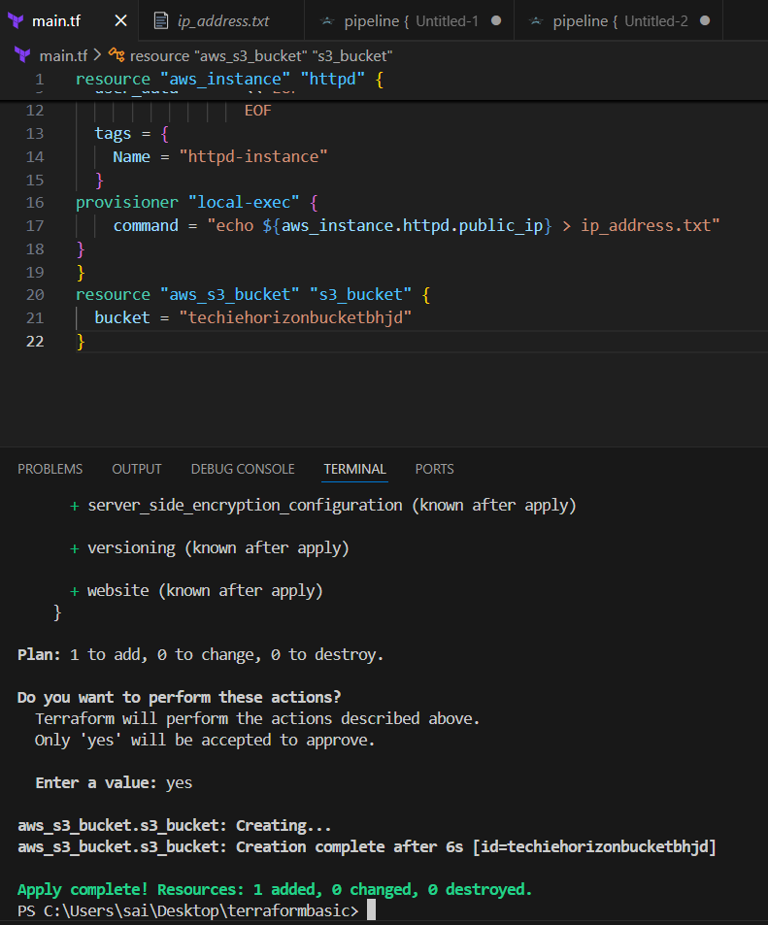
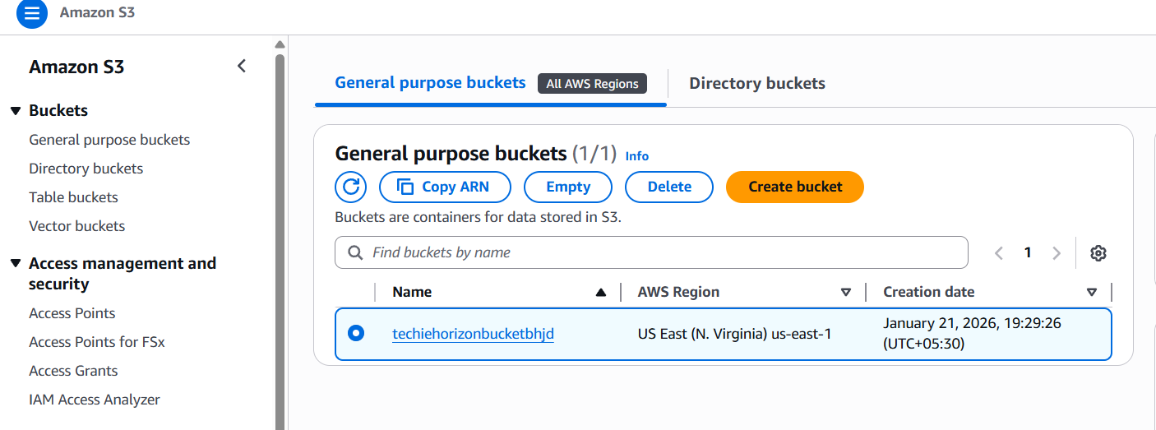
terraform {
backend "s3" {
bucket = "techiehorizonbucketbhjd"
key = "terraform.tfstate"
region = "us-east-1"
}
}
After bucket creation add above syntax to attach as backend
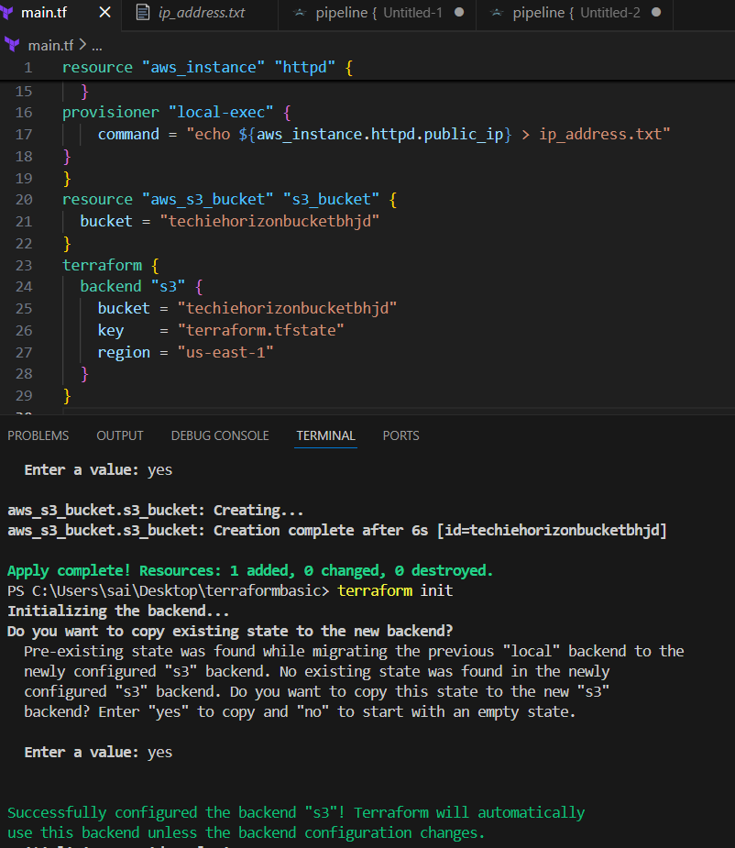
Verified in aws as state file backed up
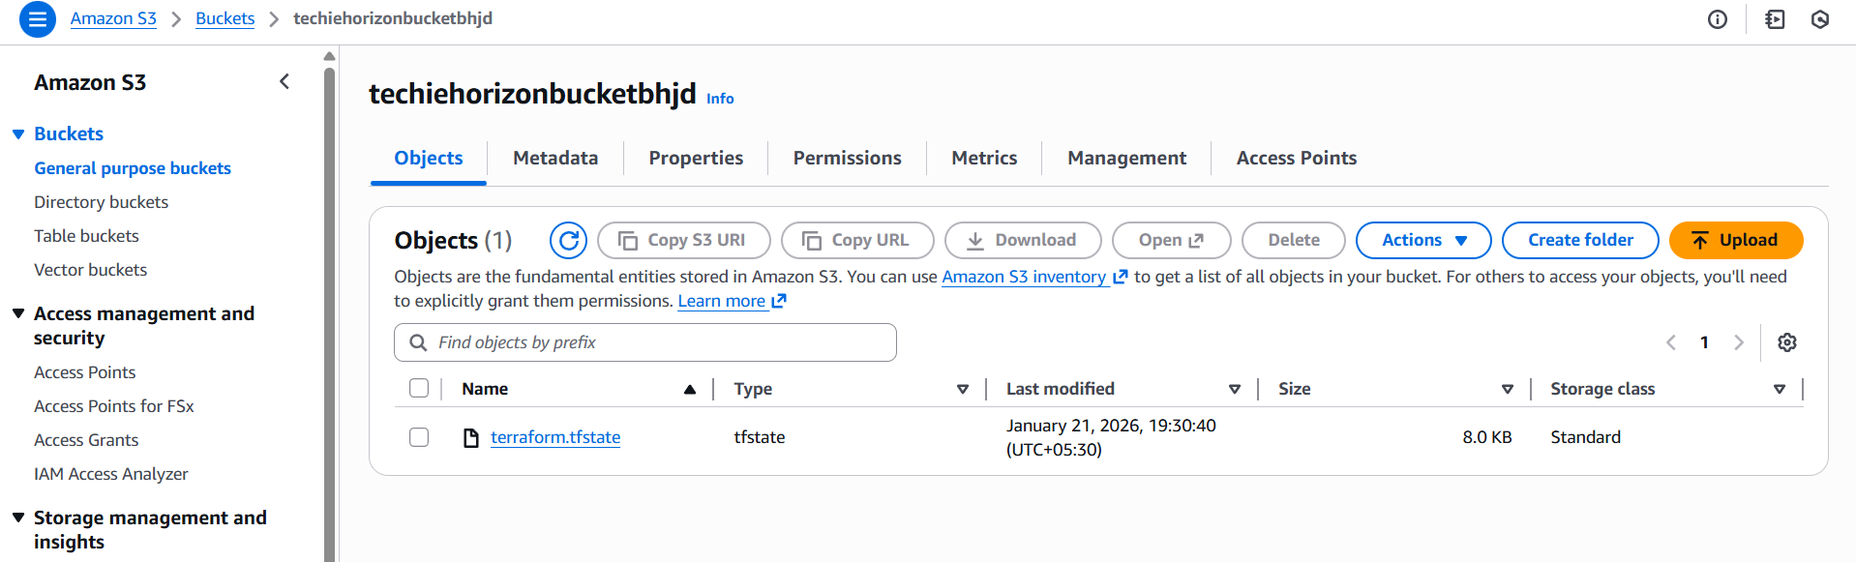
5. Set up DynamoDB locking for task 3.
Syntax:
resource "aws_dynamodb_table" "ddb-terraform-backend" {
name = "ddb-terraform-backend"
hash_key = "LockID"
read_capacity = 20
write_capacity = 20
attribute {
name = "LockID"
type = "S"
}
}
For creating dynamo db attach the above syntax to earlier main.tf file
Commands:
.init and apply

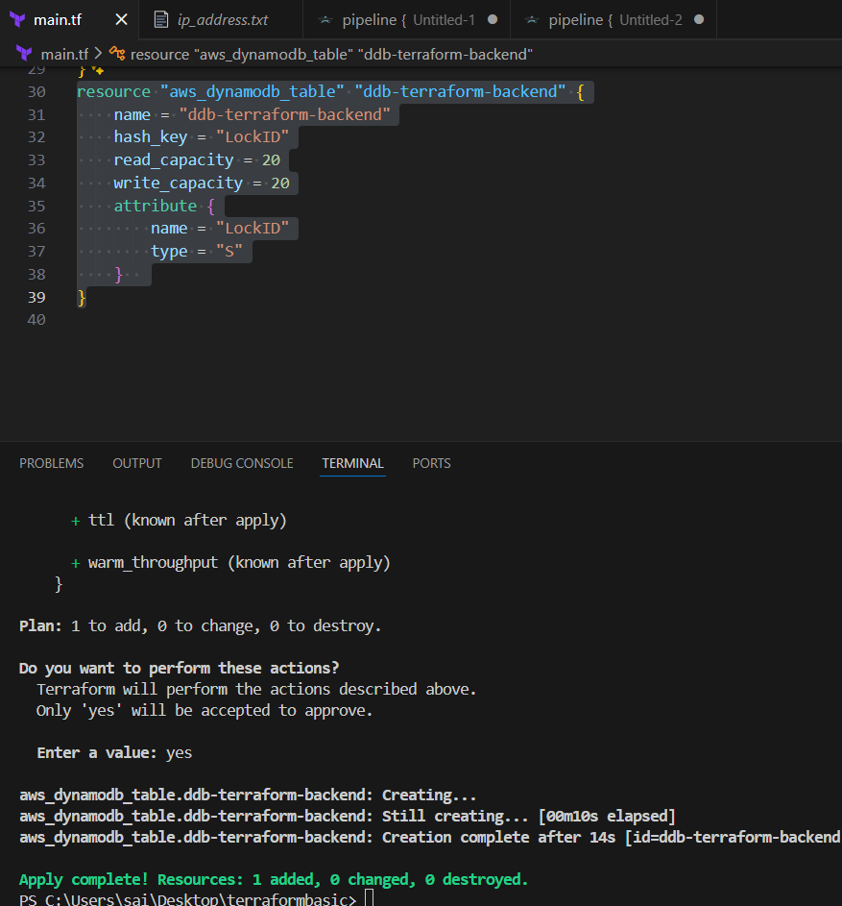
Verified in aws as created
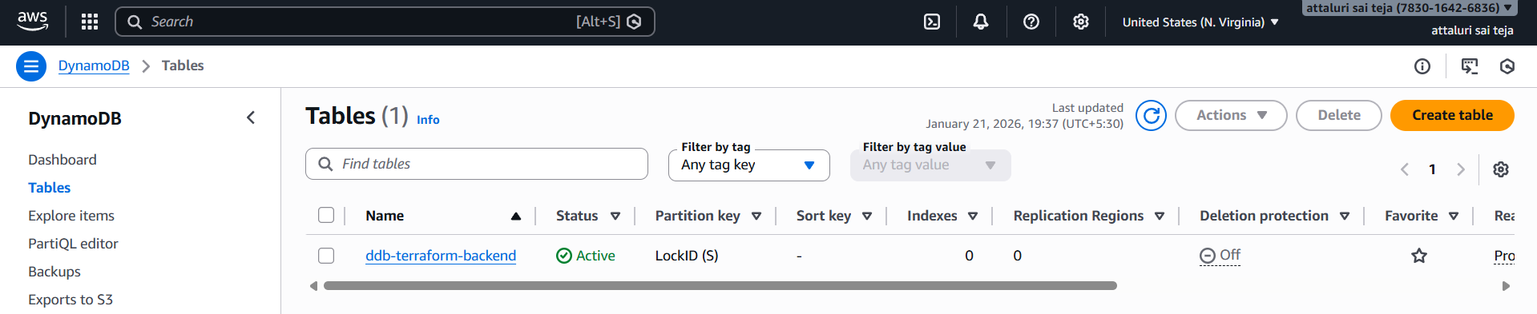

Commands terraform init
Or terraform init -migrate-state
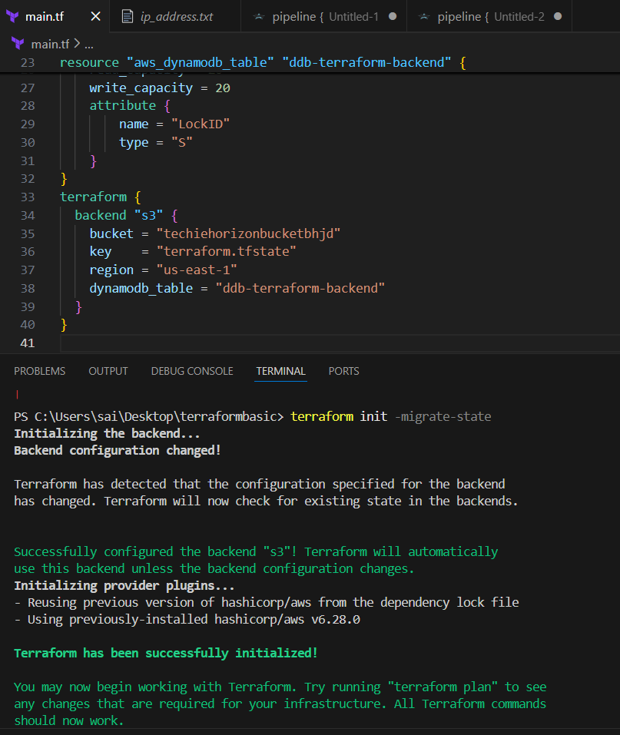

Verifying the lock using terraform apply
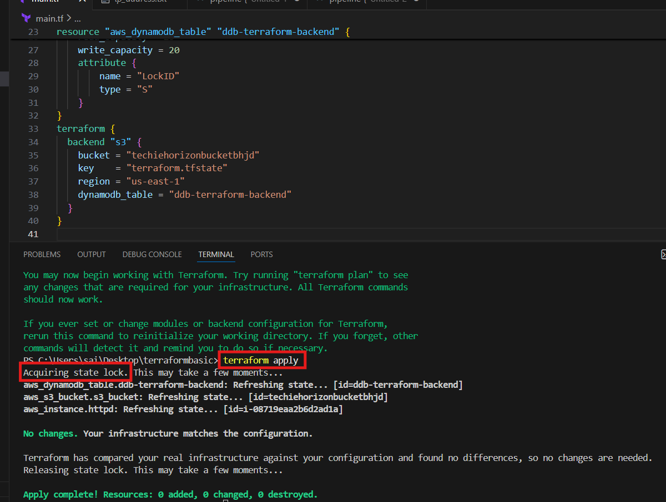
Final syntax
resource "aws_instance" "httpd" {
ami = "ami-07ff62358b87c7116"
instance_type = "t3.micro"
key_name = "sshless"
user_data = <<-EOF
#!/bin/bash
sudo yum update -y
sudo yum install -y httpd
sudo systemctl start httpd
sudo systemctl enable httpd
echo "Hello, World from $(hostname -f)" > /var/www/html/index.html
EOF
tags = {
Name = "httpd-instance"
}
provisioner "local-exec" {
command = "echo ${aws_instance.httpd.public_ip} > ip_address.txt"
}
}
resource "aws_s3_bucket" "s3_bucket" {
bucket = "techiehorizonbucketbhjd"
}
resource "aws_dynamodb_table" "ddb-terraform-backend" {
name = "ddb-terraform-backend"
hash_key = "LockID"
read_capacity = 20
write_capacity = 20
attribute {
name = "LockID"
type = "S"
}
}
terraform {
backend "s3" {
bucket = "techiehorizonbucketbhjd"
key = "terraform.tfstate"
region = "us-east-1"
dynamodb_table = "ddb-terraform-backend"
}
}

